# Mini Project #1

Name：Haoran Lou hxl180012

**1.**

**(a)**

P(T>15)=1-P(T<=15)=1- $\int_{0}^{15}{f_{T}(t)dt}≈0.397$

**(b)**

**i.**



**ii.**



**iii.**

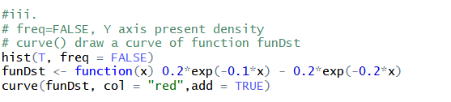

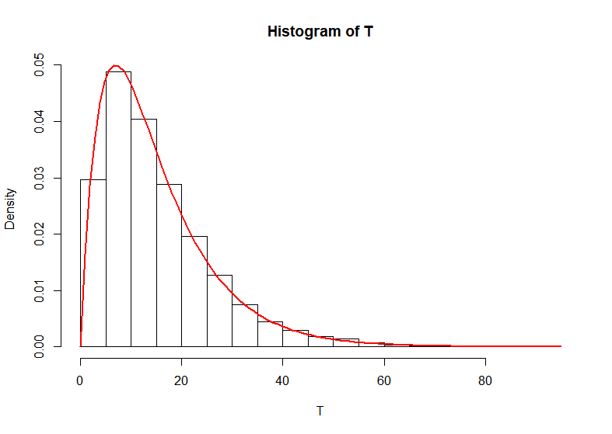

**iv.**

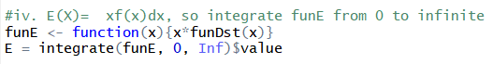



**v.**





**vi.**

I see that the values of E(T) and P(X>15) remain unchanged and very close to the computed values.

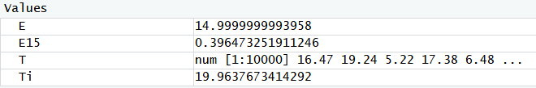

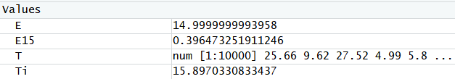

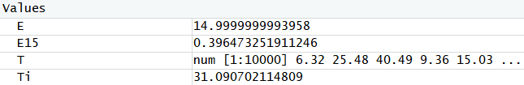

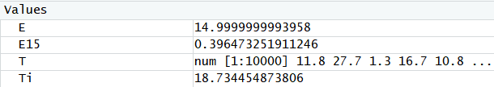

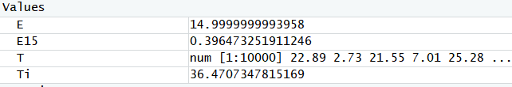

**2.**

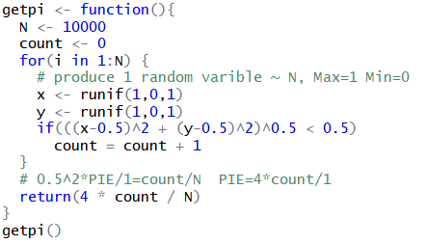

Value of PIE

|  |  |  |  |  |  |  |  |  |  |
| --- | --- | --- | --- | --- | --- | --- | --- | --- | --- |
| PIE | 3.1652 | 3.1504 | 3.1404 | 3.1432 | 3.1527 | 3.1398 | 3.1567 | 3.1467 | 3.1323 |